Chapter 7, Problem 77.

The switch in Fig. 7.141 opens at t = 0. Use PSpice to determine v(t) for t > 0.

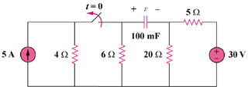

Figure 7.141
For Prob. 7.77.

